Project Planning Phase
Project Planning (Product Backlog, Sprint Planning, Stories, Story points)

Date | 30 September 2026
Team ID | 6abab772b81abcc53b06d3f7
Project Name | Import Data using Transform Maps (Spreadsheet)
Maximum Marks | 5 Marks

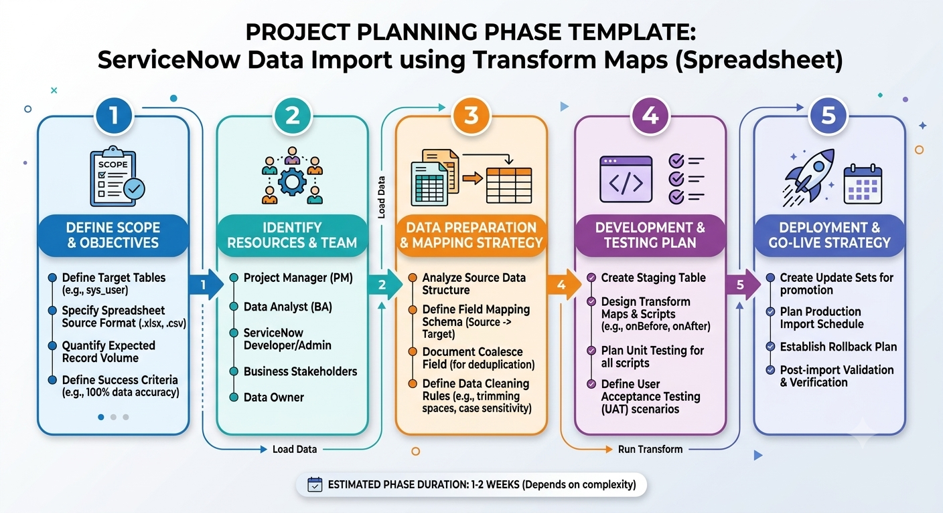
Product Backlog, Sprint Schedule, and Estimation (4 Marks)
Sprint | Functional Requirement Epic) | User Story Number | User Story / Task | Story Points | Priority | Team Members
Sprint-1 | Authentication & User Management | USN-1 | As a user, I can securely log into the system so that I can access my data import workspaces. | 3 | High | Karuppasamy, Jayaprakash
Sprint-1 | File Management | USN-2 | As a user, I want to upload spreadsheet files (.csv, .xlsx) so that I can source raw data for import. | 5 | High | Arish Mohamed, Thangaselvan
Sprint-1 | Transform Maps | USN-3 | As a user, I want to create and configure a Transform Map to link spreadsheet columns to target database fields. | 8 | High | Karuppasamy
Sprint-2 | Transform Maps | USN-4 | As a user, I want to define field transformation rules (e.g., date formatting, concatenation, default values) during mapping. | 5 | Medium | Thangaselvan, Jayaprakash
Sprint-2 | Data Import | USN-5 | As a user, I want to execute the data import process using the configured Transform Map with batch processing and coalesce keys. | 8 | High | Arish Mohamed, Karuppasamy
Sprint-3 | Data Import | USN-6 | As a user, I want comprehensive error logging and validation reports for failed row imports. | 5 | High | Arish Mohamed
Sprint-3 | Reporting & Dashboard | USN-7 | As a user, I want a dashboard summary showing total imported records, skipped records, and error counts. | 3 | Medium | Karuppasamy

Sprint Schedule & Tracking Table

Sprint | Total Story Points | Duration | Sprint Start Date | Sprint End Date (Planned) | Story Points Completed (as on Planned End Date) | Sprint Release Date (Actual)
Sprint-1 | 16 | 10 Days | 28 Sep 2026 | 09 Oct 2026 | 16 | 09 Oct 2026
Sprint-2 | 13 | 10 Days | 12 Oct 2026 | 23 Oct 2026 | 13 | 23 Oct 2026
Sprint-3 | 8 | 10 Days | 26 Oct 2026 | 06 Nov 2026 | 8 | 06 Nov 2026

2. Velocity Calculation
- Sprint Duration: 10 Days (per sprint)
- Total Story Points Committed: 37 Points (across 3 Sprints)
- Total Completed Points: 37 Points

Average Velocity (AV) Calculation:

$$AverageVelocityperSprint=\frac{TotalPointsCompleted}{TotalSprints}=\frac{37}{3}≈12.33pointspersprint$$

$$AverageVelocityperDay(IterationUnit)=\frac{AverageSprintVelocity}{SprintDurationinDays}=\frac{12.33}{10}≈1.23storypointsperday$$

